**Ideation Phase**

**Define the Problem Statements**

|  |  |
| --- | --- |
| Date | 27 June 2025 |
| Team ID | LTVIP2025TMID21127 |
| Project Name | Sustainable Smart City Assistant |
| Maximum Marks | 2 Marks |

**Customer Problem Statement – Smart City AI Assistant**

The Smart City AI Assistant is designed to solve problems faced by citizens and city administrators who struggle with understanding lengthy documents, language barriers, and manual data analysis.

Citizens and administrators struggle with long documents, language barriers, and data analysis, which causes frustration and confusion. They need a simple tool to summarize, translate, forecast, and analyze information quickly and easily.

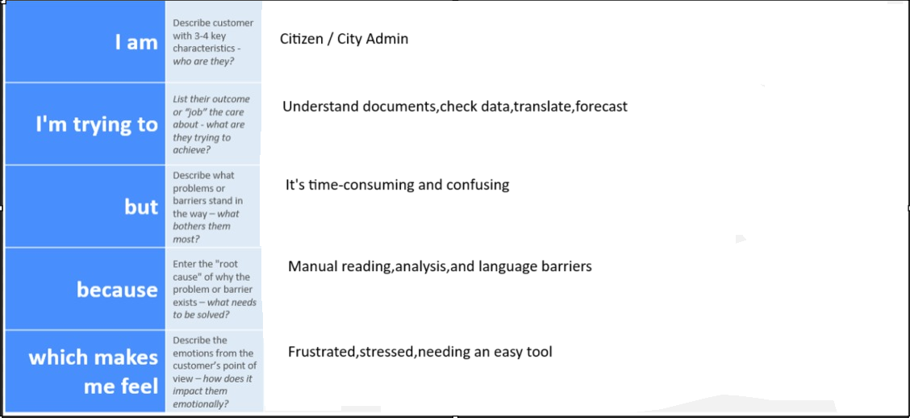

Reference: <https://miro.com/templates/customer-problem-statement/>

**Example:**

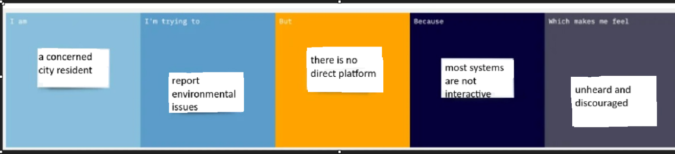

|  |  |  |  |  |  |
| --- | --- | --- | --- | --- | --- |
| **Problem Statement (PS)** | **I am (Customer)** | **I’m trying to** | **But** | **Because** | **Which makes me feel** |
| PS-1 | a city planner or government officer | understand and summarize long and complex sustainability policy documents quickly | reading and interpreting such documents takes time and effort | they are written in formal and technical language | overwhelmed and inefficient |
| PS-2 | a city resident concerned about environmental issues | report local issues and get sustainability tips | I don't have an easy way to engage with authorities or access helpful guidance | most platforms are too complex or not tailored to eco-initiatives | unheard and uninformed |